# **JMeter GUI: Test Plan & Workbench**

As soon as you launch JMeter, you will see 2 elements

1. Test Plan
2. Workbench

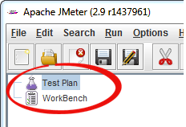

## **What is a Test Plan?**

Test Plan is where you add elements required for your JMeter Test.

It stores all the elements (like ThreadGroup, Timers etc) and their corresponding settings required to run your desired Tests.

The following figure shows an example of Test Plan

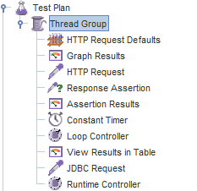

## **What is WorkBench?**

The WorkBench simply provides a place to store test elements **temporarily**. WorkBench has no relation with Test Plan. JMeter will **not save** the contents of the WorkBench. It only saves the contents of the[Test Plan](https://www.guru99.com/what-everybody-ought-to-know-about-test-planing.html)branch

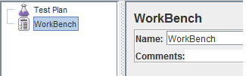

“WorkBench” will be used in our tutorial HTTP Proxy Server Recording Test

For now, ignore it.

## **How to add Elements?**

Adding Elements is the **essential** step to build a Test Plan because without adding elements, JMeter **cannot** execute your Test Plan

A Test Plan includes many Elements such as Listener, Controller, and Timer

You can add an element to test plan by right-clicking on a **Test Plan** and choose new elements from “**Add**” list.

Suppose, you want to add 2 elements to Test Plan **BeanShell Assertion** and **Java Request Default**

* Right click **Test Plan -> Add -> Assertion-> Bean Shell Assertion**
* Right click **Test Plan -> Add -> Config Element -> Java Request Default**

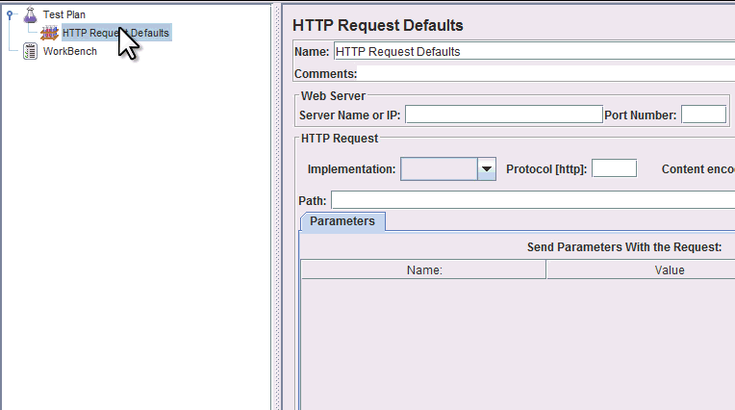

You can also **remove** an unused element

Let’s say, you want to remove element “**HTTP Request Defaults**“, select “HTTP Request Default” -> Right click-> choose **Remove** from the context menu -> Click **Yes**to confirm delete this element on message box

## **Loading and Saving Elements**

## **How to Create JMX file**

Suppose you have already added an element name “BeanShell **Assertion**“. Now you want to save it.

Right-click BeanShell Assertion -> select **Save Selection As**

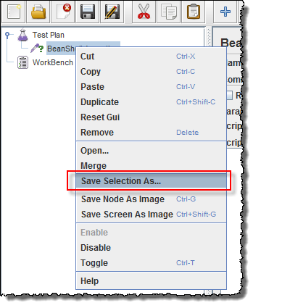

A dialog box display, click S**ave** button to save your elements under default name **BeanShell Assertion.jmx**. You can choose other names if you want

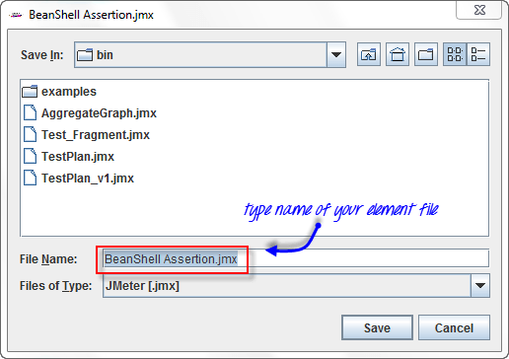

JMeter Test Elements and Test plan are stored in **\*.JMX** format. **JMX** is standing for **Java Management Extensions.**

## **How to Run JMX file**

Loading exist element helps you save your time required to create & configure new elements

Let’s say, that you have an existing element in Test Plan: **Java Request Default**

Right-click **Java Request Defaults**-> select **Merge**

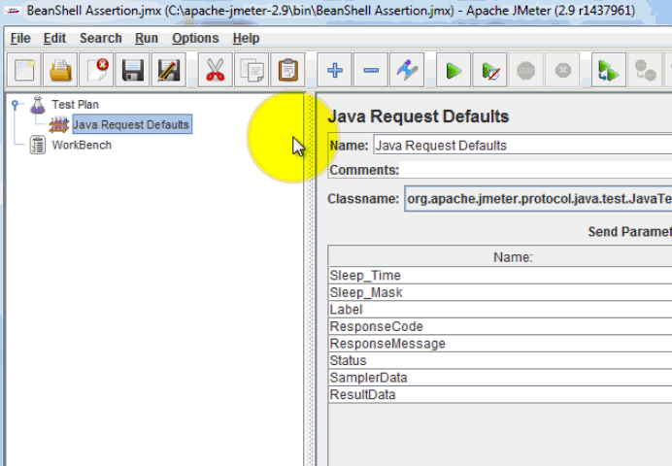

Choose the **Elements** (**BeanShell Assertion.jmx.**) file in the directory. This element will be added to your current test plan.

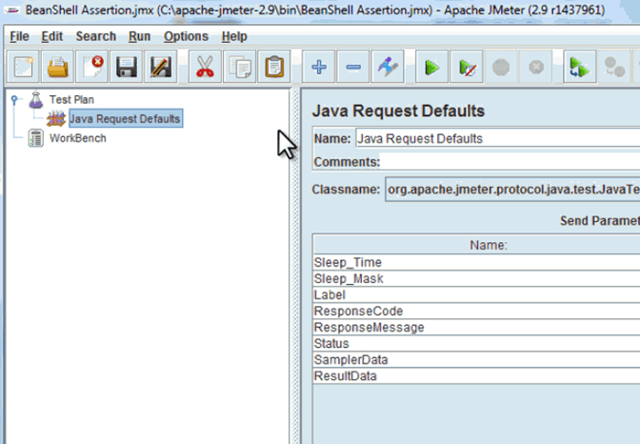

## **How to Configure Elements**

In order to configure any Element

1. Select the element in the Tree on Left Pane
2. Enter configuration settings on the Right Pane

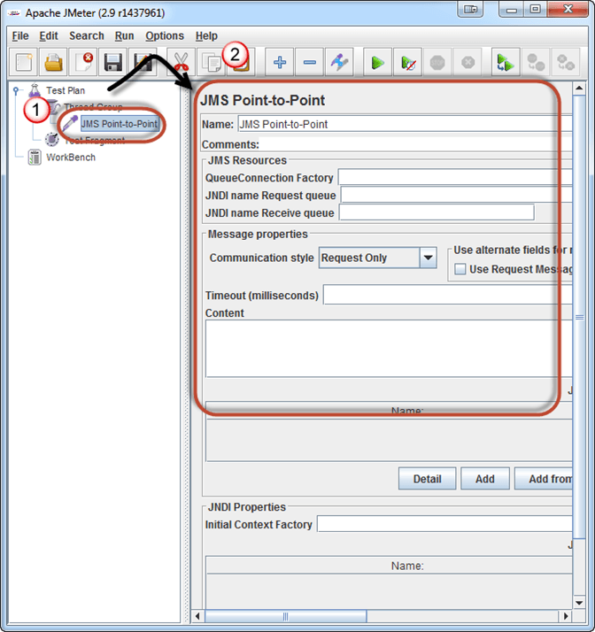

## **How to Save a Test Plan**

Before running a test, you should save your Test Plan first. Saving your Test Plan helps you avoid unexpected error when running the test plan. Steps to saving Test plan –

1. **File -> Save Test Plan as-> a Dialog box display**
2. Enter a filename of Test Plan **->**click **Save**

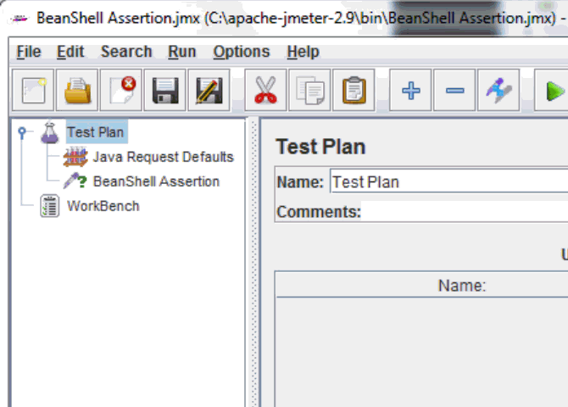

Note: Saving a Test Plan is **different** from saving elements.

|  |  |
| --- | --- |
| **Saving a Test Plan** | **Saving an Element** |
| Test Plan consists of one or many elements | Element is a basic component of JMeter |
| When you save your Test Plan, all those elements in the plan are saved | When you save your elements, only one element is saved. |

## **Create a Combo Test Plan**

You can **merge** one or many Test Plans to create a **combo** Test Plan as shown in below figure

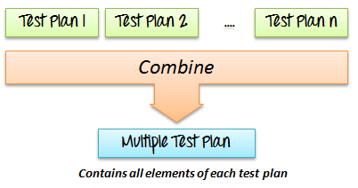

Suppose you already have an existing Test Plan name [**Test_Fragment.jmx**](https://drive.google.com/uc?export=download&id=0B_vqvT0ovzHca3g5WDJucmZmNFE) on your computer (This article includes this file). You can merge this test plan to current Test Plan on JMeter to create a new Test Plan.

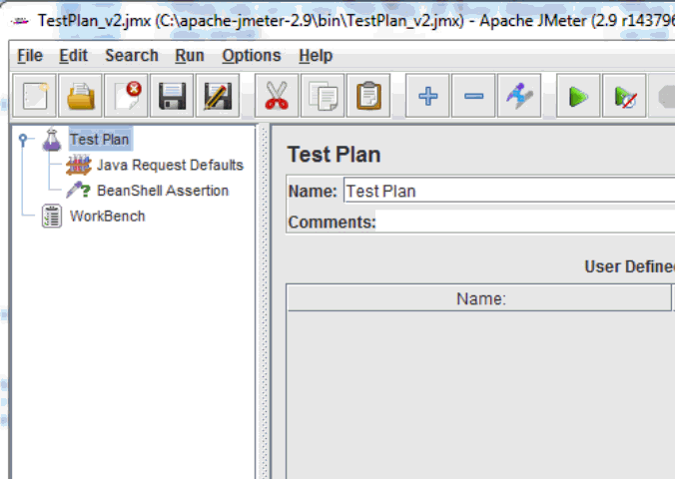

Now all the test elements in file **Test_Fragment.jmx**are added to your current test plan as shown in the figure below

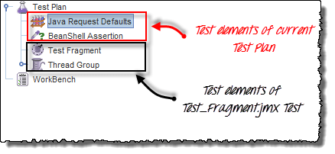

## **How to Run Test Plan**

To run your single or multiple test plans, choose **Start** (Control + R) from the **Run** menu item.

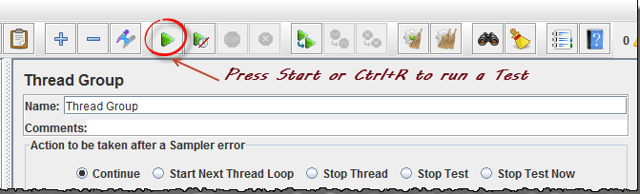

When JMeter is running, it shows a small green box at the right-hand end of the menu bar.



The numbers to the left of the green box are the number of **active threads** / **total number** of threads.

To Stop the Test, press **Stop** button or use short key Ctrl + ‘.’

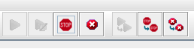

## **Test Report**

When test execution is done, you can get the test report. The test report includes the error log file, which is saved in jmeter.log, and the test results summary. Here is a sample log file of JMeter

* 2013/08/18 08:41:12 INFO  – jmeter.JMeter: Copyright (c) 1998-2013 The Apache Software Foundation
* 2013/08/18 08:41:12 INFO  – jmeter.JMeter: Version 2.9 r1437961
* 2013/08/18 08:41:12 INFO  – jmeter.JMeter: java.version=1.7.0_25
* 2013/08/18 08:41:12 INFO  – jmeter.JMeter: java.vm.name=Java HotSpot(TM) Client VM
* 2013/08/18 08:41:12 INFO  – jmeter.JMeter: os.name=Windows 7
* 2013/08/18 08:41:12 INFO  – jmeter.JMeter: os.arch=x86
* 2013/08/18 08:41:12 INFO  – jmeter.JMeter: os.version=6.1
* 2013/08/18 08:41:12 INFO  – jmeter.JMeter: file.encoding=Cp1252
* 2013/08/18 08:41:12 INFO  – jmeter.JMeter: Default Locale=English (United States)
* 2013/08/18 08:41:12 INFO  – jmeter.JMeter: JMeter  Locale=English (United States)
* 2013/08/18 08:41:12 INFO  – jmeter.JMeter: JMeterHome=C:\Nguyen\Source_code\apache-jmeter-2.9
* 2013/08/18 08:41:12 INFO  – jmeter.JMeter: user.dir  =c:\Nguyen\Source_code\apache-jmeter-2.9\bin
* 2013/08/18 08:41:12 INFO  – jmeter.JMeter: PWD       =C:\Nguyen\Source_code\apache-jmeter-2.9\bin